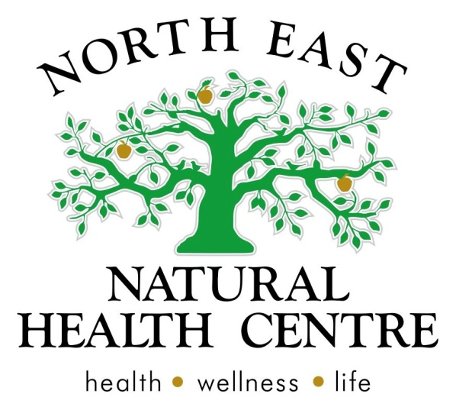

Clinic News
We hope you all had a great Easter Break and got to enjoy some family time, Easter egg hunts and some of the great outdoors.
We are back in the swing of it after our little break and this month have a bit of skin focus, with lots of ideas, articles and recipes for glowingly healthy skin. It does take a bit of work to look after your skin, especially if you are acne, eczema or psoriasis prone, but some of our new workshops and articles might help give your skin a bit of a make over.
Enjoy April and the turning of the Autumn leaves. We look forward to seeing you all soon.
Sophie, Belinda and Michelle - Naturopath/ directors at North East Natural Health Centre.
Gift Packs available
We are excited to announce that we have designed some beautiful gift packs for you to spoil all those close to you. With healthy ingredients for the mind body and spirit, well in time for Mother's day.
Here is a sneak peak of some of the packs that will be available soon. Our gift packs are suitable for all budgets ranging from $20 - $100 per pack.
Breakfast in Bed: beautiful glass tea pot, Mojo's museli and your choice of herbal tea blend.
Rest and Relax: All you need to switch off and create the perfect relax zone at home - your choice of PIA candle, Relaxing bath salts, USPA mini polish and scrub and a rest and restore meditation CD.
Mum To Be: Spoil your expecting girl friend, daughter, sister or partner with this pregnancy gift - Relaxing bath salts, mum to be herbal tea, Pregnancy meditation CD, Beautiful Belly balm (for massaging growing tums and reducing stretch) marks.
Mum and Bub New Mother: A simple gift for a baby shower or new mother - breast feeding herbal tea, Post partum recovery bath salts, baby bum balm and baby oat bath
Keep an eye on our facebook page for specific updates, availability or just pop in and browse the retail section of the clinic and front display.
Specials for Mothers Day
We also have some great specials coming up for Mothers Day. These will be available all month at the discounted rate. Specials include 2 PIA candles for $55 and a herbal tea and glass teapot for $35.

Skin Deep - a workshop for healthy skin.
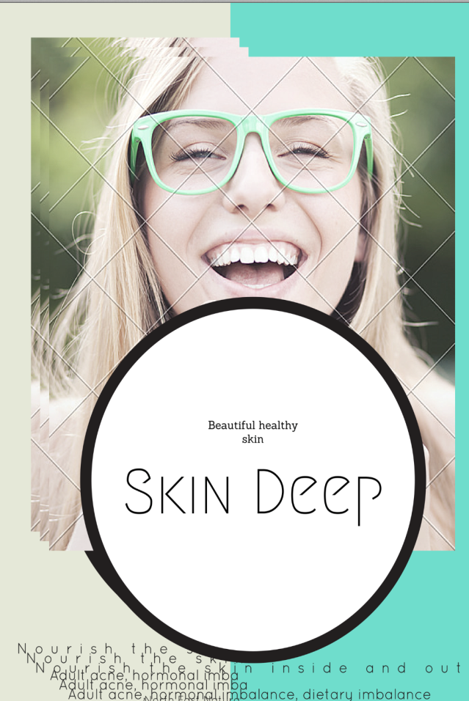
Skin deep is a workshop for women wanting healthier skin. Our skin is the surface we present to the world and so the way our skin looks and feels can directly effect our confidence self esteem and energy. It can be frustrating being over 30 and still having acne, eczema or hormonal skin flare ups. Knowing what contributes to both your skin's health and its flare ups can help you manage chronic skin conditions such as adult eczema, acne, psoriasis and poor skin luster.
In this workshop you will learn what causes YOUR skin to flare up and 3 specific ways to target the health of your skin. We will also:
- Look at how diet, hormones, stress and nutrients effect your skins healthy balance.
- Test your PH and zinc levels to see if your nutritional status is effecting your skin.
- Create an action plan to start improving your skin
- Practice 3 simple daily rituals that will help you to love the skin your in and keep it healthy between flare ups.

The workshop is running Thursday April 23rd 9am-10am, 12-1pm and 5-6pm at North East Natural Health Centre with Naturopath Sophie Lorback.
The cost is $20 and includes take home samples, information, demos, recipes, and clinical testing.
Spaces are limited to small intimate groups so please book your place via reception - 57215886.
Short Courses with Rosetta Holmes - Kinesiology.
REDUCE STRESS
Are you looking for a way to reduce stress?
Trouble sleeping?
Irritable?
Relationships?
Busy Mind?
Feeling overwhelmed?
Do you know why you’re stressed?
Do you know how to deal with it?
Maybe this is for you.
Allow yourself 3 x 90 minute group sessions to learn in a safe environment, strategies that will help you.
Due to demand and limited spaces for 8 participants only.
This short course this will commence Wednesday 22nd April, running consecutive Wednesday nights
29th April and 6th May from 7:00pm to 8:30pm.
Bookings essential to secure your place
Cost: $79 per Workshop ($50.00 deposit required upon booking)
Early Bird Special of $220.00 if paid by 20th April 2015
To REGISTER please contact Ashton at North East Natural Health Centre on (03) 57215886

Support Alannah at the Special Olympics
Alannah McKeown is 18 years old. She loves music, dancing, fashion, shoes, handbags – and swimming! Alannah has Down Syndrome and she has earned an amazing opportunity - to be one of only 8 swimmers to represent Australia at the Special Olympics World Games in Los Angeles in July 2015 – and the only swimmer from Victoria invited to attend. Alannah is seeking support to raise the funds needed ($8,250) to make this possible.
Alannah’s Special Olympics story began in 2012. As the sole competitor for the Ovens & Murray Region, she swam in a Regional competition that year, followed by State Games in March 2013. Another competition in May 2013 then the honour of representing Australia in the Asia Pacific Games in Newcastle that December, winning the first Gold Medal of the competition for her country! Alannah represented Victoria in the National Games in October 2014, earning a gold medal for her 50 meter backstroke event. It was this win that qualified Alannah to be in the draw to be part of Team Australia, and to compete in the 2015
World Games.
Donations can be made directly to Alannah via:
Westpac - BSB 733 264 - Account 657565 - Account Name: Alannah Jean McKeown
Alannah and her proud family thank you for your interest and support. Please know that all donations of any amount will be greatly appreciated.
Follow The Special Olympics World Games story and Team Australia’s journey at: http://www.la2015.org and http://www.specialolympics.com.au/teamaustralia
Alannah’s achievements and the local Special Olympics swim squad was recently featured in our local paper -
http://www.bordermail.com.au/story/2863053/alannah-an-inspiration/?cs=10
Donations can be made via the Special Olympics website,
https://specialolympics.myetap.org/fundraiser/worldgames2015/team.do?participationRef=867.0.74571136
However, donations made this way go to a team fund and are shared between the 8 swimmers to reduce everyone’s debt.

Articles and Information

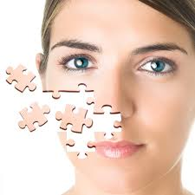
Adult acne: finding all the pieces of the puzzle to create healthy skin.
By Sophie Lorback - Naturopath
I’m 30 and my skin is still acne prone? Help me out!
Pimples and low self -esteem are most frequently linked to teenagers, but frustratingly more and more women over 30 are still acne prone.
No matter what your age, clear skin is sign of good health but is also important in helping to develop self- confidence and positive self-image. Naturopaths aim to first determine the cause of your acne be it hormonal, stress induced, dietary or inflammatory and then come up with a strategy to improve the health of your skin. Sometimes it can be like putting all of the pieces of a puzzle together. Once we know all the contributing pieces we can aim to correct them.
Where your pimples are located may point to their cause. For instance, pimples on the cheeks are often the sign of a food intolerance such as dairy, whereas cyst-like pimples along line the jaw are most likely to be hormonally triggered. Hormonal outbreaks also appear on the chest, back and shoulders. Small pimples, with red surrounds grouped closely together signify a localised infection just under the skin. Removing sugar from your diet will help in addition to taking blood purifying herbs that are mentioned below. Pimples on the forehead may be due to stress, or if there is a fringe, excess sweating. Pimples on the chin reflect poor digestion or constipation.
Sometimes we combine dietary changes with natural medicines, and sometimes we combine these with medical treatments. Everybody’s skin is different and individual assessment and treatment can lead to better results.
Naturopaths approach to acne flare ups:
Dietary causes: a regular intake of low GI whole-grains along with lots of fresh vegetables and lean proteins (clean eating) has been proven to improve acne in 12 weeks. We have a food-based program that can be easily adapted to teens or adults.
Hormonal influence: our stress hormones and insulin signalling hormones have a marked effect on our levels of testosterone and oestrogen. When these are unbalanced we can get skin breakouts and have trouble controlling acne. Nutritional and herbal medicines can be a safe and effective way of improving skin at times of key hormonal changes.
Balance blood sugar levels: eating a regular intake of low GI foods and lean protein will balance blood sugar levels, lowering insulin and controlling hormonal fluctuations. This can balance mood, increase energy and improve the look of your skin. This is especially important for those of you who have a family history of diabetes, have energy dips after lunch or have a know diagnosis of PCOS.
Too much screen time: too much time indoors depletes your absorption of vitamin D which is needed for healthy skin immunity. Side effects of too much screen time include striping your skin of vitamin A, which also protects the skin from infections and acne.
Love the skin your in
By Naturopath Sophie Lorback
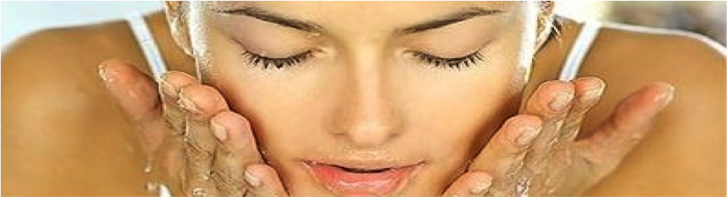
Our skin is our largest organ and the way we present to the world. When we are unhappy with the look of our skin, it can cause a lot of distress.
Of course, we know that a little bit of acne, tinea or eczema is not that big of a deal compared to a life threatening illness, but that dose not stop us constantly worrying about how our skin looks and feels.
Some people are lucky enough to inherit gorgeous skin, and can apply any number of creams, soaps or eat what they like, without having any obvious damage to the skin. Many of us however, have to work pretty hard to keep our skin happy and healthy. Because everyone can see our skin as soon as we step outside into the world, our physical skins appearance directly influences the way we view ourselves.
It is easy to think that we only need to watch what we eat when we are overweight or trying to loose weight, but for those of you not blessed with naturally radiant skin, what you eat will play a large role in the health of your skin as will the effects of stress and infections.
Interestingly, we use the same nutrients to balance our moods and hormones and fight infections as we do for keeping our skin healthy, so at times of stress or colds/infections or hormonal changes (PMS) you may find your skin worsening.
Once you know which nutrients you are deficient in or prone to using up in larger amounts in these other situations, you can ensure that you eat more of them in your foods, or increase doses of supplements during these times to prevent your skin from falling apart too.
Red skin, itchy skin, allergic skin and hormonal acne all impact the way we feel and you don’t have to put up with it. Ask your naturopath to help you determine the cause of your skins poor health so you can manage the look and feel of your skin with more control and start to feel more confident.
The Skin Connection
By Rosetta Holmes Kinesiologist
Your skin is a remarkable self-renewing organ measuring up to 2 square meters in diameter and is part of a system which incorporates hair, nails and glands.
Due to its connections with the internal body it can indicate when things are out of whack. In fact, if your skin is suffering on some level then perhaps your internal body is also.
Our physical body responds to stressors and those stressors could be anything in your environment that puts your body as a whole under pressure.
Simply put; your thoughts affect how you feel and your emotions affect how you think, influencing your behavior. The results of that behavior affects how you think and feel!
It’s like when you praise a child for their exceptional behavior, they feel great, confidence grows and they think well of themselves. It is highly likely they will repeat this behavior (action).
The same applies for example, if a child feels embarrassed in public from something they said, they will think poorly of themselves, feel terrible and will be less likely to share their opinion (action) next time. A flow on effect of a situation like this could be that they go off their food or don’t sleep well which can affect their nutritional absorption. This stress can affect their skin through dryness or irritation like dandruff or eczema.
As a busy parent perhaps you can relate to life getting ‘crazy’ with school, home, sports.…..etc, it’s easy to get caught up with it all and lose track of ‘self-care’. Before you know it, your ‘under the pump’, irritable, not eating well, rarely smiling, rushing and just feeling overwhelmed. Your lower back starts to ache and your mind just won’t shut off! You’re in need of a hair appointment, your nails are chipping and skin looks dry. And you’re waiting for school holidays to arrive!
Is your skin telling you, you’re stressed or overwhelmed?
Look out for my upcoming short courses.
Rosetta.

Product of the Month

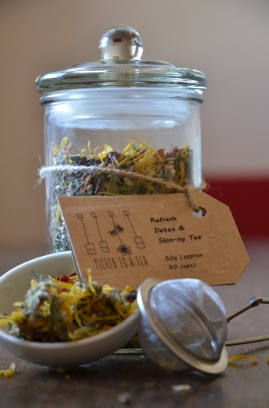

Skin and Detox tea
This tea is perfect for your change of season skin cleanse. As we approach the cooler, windier months our skin can easily dry out and those red spots can be aggravated. Stay hydrated and nourished with this refreshing detox and skin tea. Full of lovely tasting herbs such as calendula, peppermint, lemongrass and antioxidant berries.
Available in glass jars $20 or paper bag refills $10.
For the full Picked to a Tea range click here

Recipe of the Month

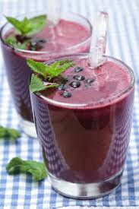
Skin Juice
A daily tonic and ritual to revamp your skin
1 handful of berries, 1 cucumber, 1 celery stalk, small handful of fresh mint, 1 tsp coconut oil.
Combine in a juicer and drink 1x a day.
** Similar variations of this juice can be purchased from juice bars and cafes if you are unable to make your own.
For more recipe ideas for your skin and general health click here

