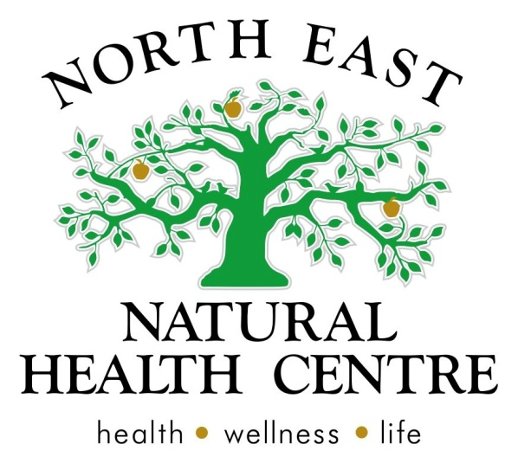

Clinic News
Welcome to wonderful winter and a bumper issue for our winter newsletter! Snuggle deep in your warm bed and enjoy the read. It's time to get out your wooly jumpers and slippers again and try NOT to resist the need to exercise outdoors! Don't forget that your body needs to move everyday, so put on your warmest coat and scarf and hit the pavement with your pets you will be amazed how warm you can feel in as little as 15 minutes and how this lifts the winter blues away too.

Clinic News
There is so much to share with you!
NEW CLINIC BABY IS ON THE WAY - SOPHIE IS PREGNANT.
Hello, it's Sophie here and I wanted to let you all know that I am pregnant and expecting my first bub at the end of August. Many of you will have already noticed my 'bump" and as such we have spoken about continuing your care and the handover process to Belinda and Michelle whilst I am on leave.
For those of you I have not yet spoken to, please discuss a plan with me for your ongoing scripts or follow up care. I will be continuing to see clients right up until August and can easily set you up to continue your health goals with Belinda and Michelle whilst I am away from the clinic getting to know my new bub :)
Further studies and a natural approach to Women's Health by Sophie Lorback
I am also really excited to tell you that I have been doing some further studies for optimizing fertility outcomes, pregnancy and general women’s health. By December I will be qualified as a Natural Fertility Educator and I am looking forward to returning from maternity leave to work with more women to achieve hormonal balance, energy and pregnancy outcomes, either naturally or by combining natural medicines with medical fertility specialists.
NEW! HOT STONE MASSAGE @ USPA DAY SPA UPSTAIRS by Michelle Cose
A day spa experience is a fulfillment of a bucket list moment - an absolute 'must try' experience.
Imagine the feeling of being wrapped in warm towels in a beautiful smelling room with gentle music all around, while warm fragrant oils are massaged into your muscles and skin. As you drift to a state of pure bliss and relaxation, heated smooth volcanic stones are used to massage the body from head to toe. If you can stay awake throughout the entire 1 to 1.5 hour treatment, you will be one of the rare few. When you awake, you may just float out of the room a relaxed and more centered version of your former self.
Uspa is a personal experience and the room is yours and the therapists only, so there is a sense of complete discrete comfort for everyone. Towels cover your private body parts to respect your body and create a safe, comfortable moment.
Hot stone massage is now available as part of our USPA upstairs day spa menu.
Gift vouchers are also available.
Click this link to see the full day spa menu.
http://www.nenaturalhealthcentre.com/uspa---tree-top-spa-retreat.html

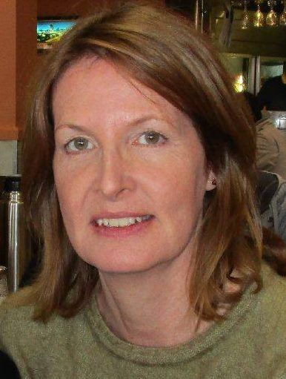
NEW PRACTITIONER STARTING TUESDAY 2ND JUNE.... PETRINA WILLIAMS, PSYCHOLOGIST
We warmly welcome Psychologist Petrina to the team. Here is a message from Petrina.
"I’ve been a registered psychologist for 17 years, working in areas as diverse as Oz Child, Centrelink, the ADF and general counseling. For the past seven years I’ve been working as a counselor in private practice at a local psychology service.
My passion has always been a more holistic approach to psychology.
I have practiced meditation for 16 years and used a number of complementary therapies myself.
I primarily provide counseling for clients aged 18 and over in the following areas:
Depression Anxiety Grief and loss Stress
Fears and phobias Relationship issues Parenting Work-related issues
Social skills training Enhancing happiness, optimism and resilience
Self-esteem Assertiveness
The main techniques I use are Acceptance and Commitment Therapy (ACT) and Cognitive Behavioural Therapy (CBT), meditation and mindfulness, as well as practical, problem-solving skills.
Clients who are eligible for a Mental Health Care Plan through their GP (e.g., for depression and/or anxiety) receive a Medicare rebate for their counseling sessions."
INTRODUCING OUR NEW RECEPTIONIST ISABELLA WILLIAMS (ANOTHER WILLIAMS, BUT NOT RELATED TO PETRINA)
You may hear a beautiful soft voice on the telephone which sounds a lot like Ashton's voice. This is the lovely Isabella Williams who has joined us as as our new receptionist as our clinic expands. She is more than happy to help you with your bookings and inquiries. We warmly welcome Isabella.
SHARE TABLE - Loads of winter garlic ON SALE HALF PRICE! (while stocks last!!)
Our locally grown, organic Killawarra garlic is on clearance sale now! It is just beginning to sprout which amplifies its best properties. Roast an entire unwrapped bulb in the oven for 45 minutes to create a delicious squishy garlic for your roast meats and roast veggies or put it on to your kid's toast for a natural antiseptic garlic bread to keep infection away.

Workshops
Back by popular demand...Skin deep.
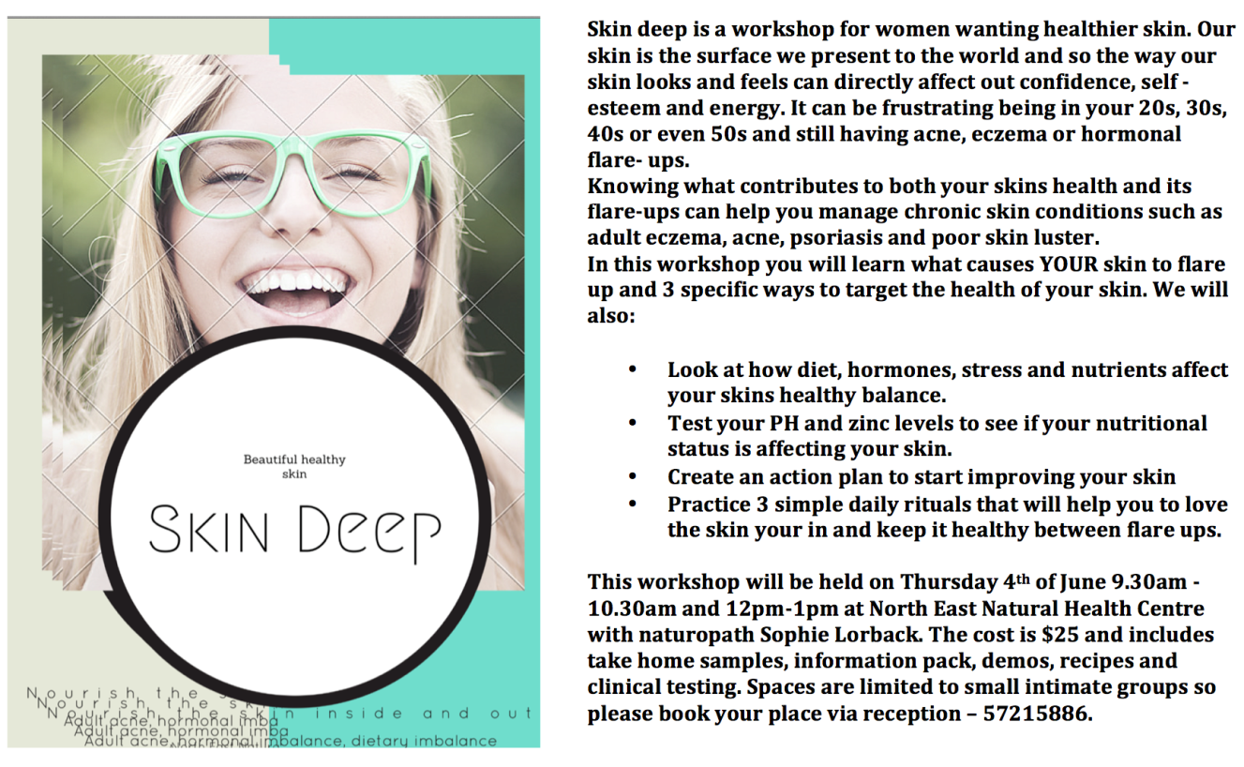
Workshop bookings are essential and places fill very fast, so call to avoid disappointment. Call 57215886
Articles and Information

Winter blah….Article by Belinda McPherson
@ North East Natural Health Centre. Ph. 57215886
The winter blues normally hits you when it’s been cold and miserable for a while and you have the overwhelming feeling of being cold to the bone, tired, you have no motivation and you just can’t seem to get it together. At this point you realize your body isn't working at its best; your bowels have slowed down, you are bloated and your exercise routine consists of walking to the car to go to work, or finding the remote for the television. You avoid social gatherings and you just can’t manage to stay on task.
For most people the winter blues can hit after a cold, you get sick and then 3 weeks later you realize that you are still tired, headachy, moody and struggling to get out of bed. Most of us experience a mild drop in mood and feeling like we can’t be bothered at this time of year, but for some the depression type symptoms are debilitating.
Naturopaths top 5 tips to reduce Winter Blues...
- Take a mini break: a weekend or even better a week away in sunshine gives you that boost of Vitamin D your body is looking for. Even a daily brisk walk at lunch time will boost your moods; improve energy and your productivity in the afternoon.
- Hydrate: What do fluids do when they get cold? They slow down their movement and get thick. So keep your warm decaffeinated herbal teas, soups, broths and warm water with lemon or lime in it up. This will help reduce blocked glands and reduce aches, pains and headaches. Aim for a minimum of 1 litre of decaffeinated fluid a day. See our website for recipes or our herbal tea range.
- Exercise: keep moving! Hire a treadmill for the winter, get some workout DVDs or YouTube Pilates/yoga classes. Movement increase circulation of fluids. Circulation of fluids= delivery of nutrients and improved moods.
- Make the most of indoor time: clean out cupboards, stock the freezer with bone broths, smoothie packs, casseroles and make ahead meals. Ensure you are utilising your herbs and spices to boost your immunity and improve circulation. Or start a hobby, painting, crafts, reading etc.
- Herbal medicine: help boost immunity, improve recovery and resistance to winter bugs as well as improving energy and mood.
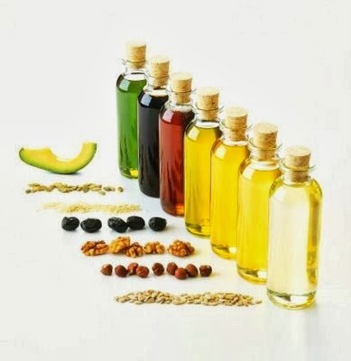
So if you have or are suffering from a drop in mood or motivation/energy through winter, give us a call and we can help you have the energy you need to get the best out of our beautiful region this winter.
Natural Energy Boosters - by Rosetta Holmes - Kinesiologist,
(Inspired by Nevena.)
Time and space is filled with all sorts of things from watching a movie to the countless deadlines being met.
The way we live influences the natural energy flow we experience and it’s all too common that people in general are feeling more and more depleted of energy to sustain the life they lead.
It’s all a balancing act.
click on this link to Rosetta's blog to find out more...
http://essentialdifference.com.au/blog/
Oils for winter chest barrier and skin health
article by Michelle Cose
Some of you may remember from years ago the daily practice of being lined up by your parents and fed a tablespoon of cod liver oil! Yuck! But the wisdom behind it was that it protected all your inner linings from infections such as colds and flu, helped allergies and asthma, was high in vitamin A and D for amazing supple skin, lubricated your joints and moisturised your digestive system to stop constipation.
I love seeing patients with healthy, glowing skin as this is the best reflection of whether or not they have a good enough intake of healthy oils in their daily food intake. It is not unusual for people of Mediterranean decent to have one-third or half a cup of cold pressed olive oil daily, dipping breads, adding to vegetables or salads or using it in sauces and casseroles. Their skin often reflects the healthy intake.
Thankfully we have refined the practice of taking cod liver oil and can now enjoy good fats in the form of salad dressings, Greek dips, pesto dips, nuts and seeds, tuna and salmon, flaxseed oils, chia seeds and seed breads, olive oil on whatever you can get it on!! and even use coconut oil in bliss balls for snacks.
Have a look at your skin? Are you lacking in good oils too? No matter how much moisturizer you use or how much water you drink, it will not fix a skin without oils.

Recipe of the Month

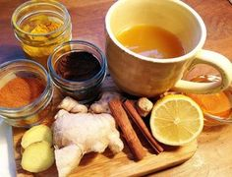
Flu bomb
1 or more cloves of garlic
1/4 teaspoon cayenne pepper
1/4 teaspoon chopped ginger
1/2 drops tea tree oil
juice of one lemon
1 teaspoon honey
add little hot water and blend
Take 2-3 times on the first day of illness and then as take as needed.

