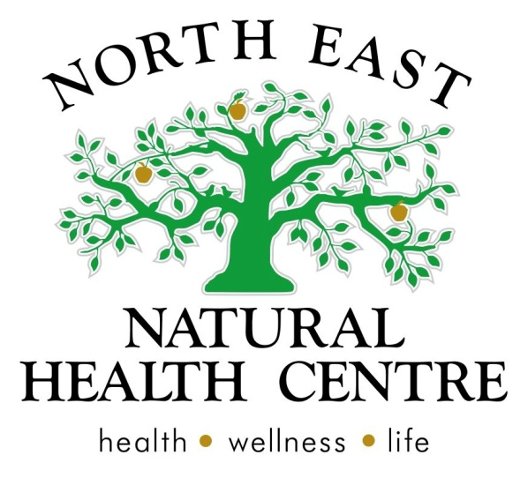

Clinic News
Summer has passed us by and we are now moving into Autumn, a beautiful time of year to explore our region. It's time to get out and about, moving those bodies and boosting your energy.
This month we are focusing in on heart health at the clinic with recipe ideas to keep your heart in good shape and some articles below to give you some tips about the emotional aspects of our hearts.
If you are a health professional looking for a place to work, you may want to give us a call. We have a room available that would suit an established practitioner, looking to build their client base. See below for more details.
We hope you enjoy the read and pop in to see us soon.
Sophie, Belinda and Michelle - Naturopaths/ directors at North East Natural Health Centre.
Recipes and reading
If you love healthy cooking and reading up on health and wellbeing, then head to our website. We have added a rescources page for all our clients and friends with healthy receipes for all occasions and book reviews.
Food and recipe ideas can be found here.
While mind food - books and reading ideas can be found here.
www.nenaturalhealthcentre.com
Share table is back
Thanks to the rain, our clinic garden is starting to grow and we have more produce available to share. Come into the clinic and swap some produce, we have lots of herbs too.
Professional Rooms Available
We have professional rooms available in our award winning multi-modality clinic. If you would like to be apart of our team, please contact reception to book a time to speak with our managers. Rooms will best suit a health consultant, massage therapist or other natural health practitioner.

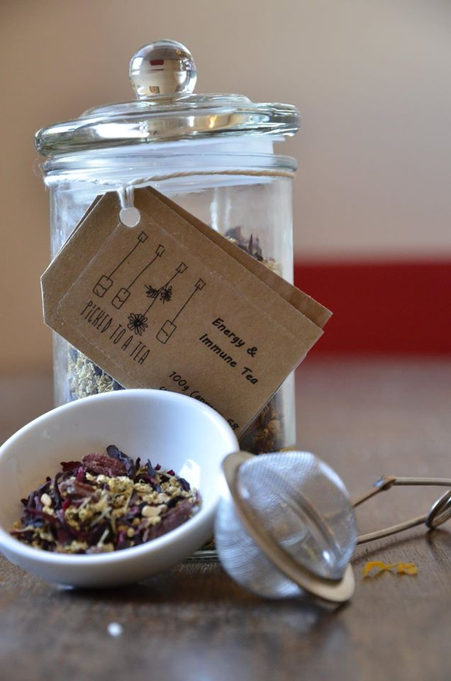
The first Herbal Tea Workshop

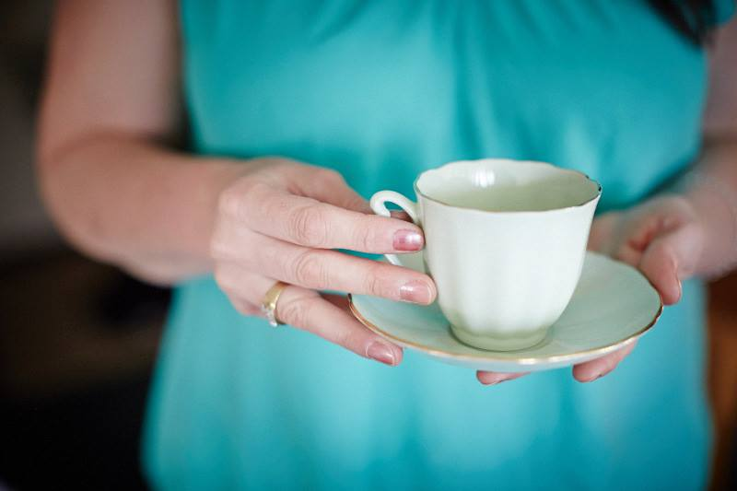
Last Tuesday night Sophie from NENHC and Eric (Cafe Deraillier) teamed up to present the first ever herbal tea workshop in Wangaratta to a sell out crowd.
We shared stories, the history of tea, explored the health and wellbeing benefits of herbal teas, had taste testings and demonstrated many brewing, presentation methods of herbals teas. The Eric shared his top secret Iced tea recipe with us.
What a great night with great people!
If you missed the workshop, don't worry we had so much fun that are planning these to be a regular event with dates coming up in March and April. So stay tuned to the Facebook page and website for more updates.
Workshops and programs
Sophie, Belinda and Michelle have been working really hard this year to develop more clinic workshops and programs aimed at teaching and educating our clients about health and wellbeing in groups. We look forward to unveiling some of these soon. keep your eye on the website for details.
Better the devil you know, than the devil you don’t…. OR IS IT???
By Rosetta Holmes Kinesiologist
January’s Newsletter provided a guideline to a divide and conquer approach to what you want in 2015….click here to read more
We took a glimpse at our alignment and what makes you tick in February with 6 simple steps ….click here for more.
March holds the door open to possibilities…
But first I want to share with you that while sitting at my kitchen bench making notes for this very Newsletter my 11 year old came up to me, looked over my shoulder and began to read what I had written. He then shared something I will share with you…. As he stood up, he simply said, “You’re talking about your tool box. A tool box has all your skills in it to help you fix problems in your life’. Without another word spoken, I watched him continue on his way with a warm smile! And he’s right! We each have a tool box with which we add to over time the skills and strategies we learn to call upon at any given time according to the situation at hand.
It can be difficult to achieve new things with the same tools and approach we have always used. So how do we broaden our approach and diversify our skills??
We practice… Opportunities are always abound. They are often waiting to be noticed. At the brink of frustration – stop, breath, notice your body, breath, think ‘how else can I do this?’ breath, smile. The answer will come to you. So I encourage you to think outside the square and be open-minded as to how you can achieve what you want.
To help you feel empowered, join me in a safe, confidential, nurturing space where we will explore strategies, activities and stories that will warm your heart and inspire you to discover more of you and to live more of your life! Stay tuned for details coming very, very soon!

Articles and Information

Introducing your heart - The greatest pump ever!
Did you know that your heart started beating when you were less than one centimeter tall within your mother’s womb?
Thanks also to great electrical wiring that sparks off signals to the heart muscles, your heart has beat or contracted around 100,000 times every day since that moment!
So we agree that it is probably the hardest working muscle in your body? Yes it is! Imagine a gym workout where you move one muscle 100,000 times in 24 hours?
So do hearts get tired? Yes!
Your heart requires enormous amounts of energy in the form of Phosphates (ATP) as well as other minerals to help phosphates be produced, such as Magnesium (to flex), Potassium (to energises), Calcium (to relax between beats), Co-enzyme Q10 (to drive the energy production) and vitamin B (for phosphate energy production also).
Consider these like “super phosphate” fertilizer for the heart. They are a booster that needs to be applied when there is less than adequate nourishment for the heart to function at its best, combined with trace minerals for long lasting strength. In an ideal world we would get most of these from fresh and natural (non packaged) foods, however there are many conditions where the heart needs a fertilizer like supplement boost to work at its best.
If you have low energy already despite eating well, or are not eating fresh foods, have poor digestion and therefore not absorbing your food well, are using digestive medications (nexium, losec or antacids), are under stress, exercising above average, not sleeping, going through hormonal change or growth or in the second part of your life you may be in need of a supplement boost.
In practice we find that patients describe themselves as having more energy overall, warmer hands and feet, better concentration, clearer head, more motivation and enthusiasm, more joy, less heart discomfort and better wellbeing when they get good advice and treatment on how to energise their heart.
(If a patient is on existing heart medication, there are always cautions to adhere to when prescribing so do not self prescribe without professional advice)
Put it this way, would you run a marathon without preparation and nourishment? Your heart is running a marathon as we speak! Fuel it correctly and it is less likely to malfunction.
Over the next 3 weeks we shall explore both the physical “pump and pipes” as well as the emotional “warmth and flow” side of your heart and circulation so you can get to know that beautiful heart within you and the amazing job it does each and every day.

'Heart Warming' communicating for a healthy heart
We communicate with many people every day, however due to time constraints, awkwardness or frustration, our communication can lack the “heart warmth” of genuine authentic communication.
“How are you?” “I’m fine thanks”...even when you are not!
“Heart warming” communication is where we truly understand each other through compassion (like a best friend). The interaction is uplifting, not draining and leaves a lasting effect on us.
The heart and mind are in partnership in our body.
Our mind is like a data processor – taking in all we see, hear, touch, taste and smell. Thoughts go back and forth in our head like an angel (good advocate) and devil (bad advocate) sitting on our shoulder, weighing up all sides of the information. Until we make a clear decision about the information, these thoughts can spew forth in conversation – A kind of “thinking out loud”.
Once the mind has found its comfortable balance point, it relays this information to the heart where it always aligns with our deep inner values of compassion, love and personal self worth...who we are at our core and what we truly believe in.
Head conversations begin with “I think..”. They can be chaotic, confronting and uneasy initially. The person may contradict themselves as they speak also. They can be stressful and argumentative.
Heart conversations begin with “I feel...”. They are personal, authentic and blame free. They feel comfortable and settled as they mean a person has drawn a conclusion and is ready to take personal responsibility. Having a heart based conversation is very honest and very connected to that persons core values.
Here are some ways to help you achieve a fulfilling connected communication:
- If a friend is speaking from their head “I think..” help them get clarity by asking them about their thoughts. Look well beyond the words to find the essence of what they are saying. What are they really meaning?
- Don’t think you know what they are about to say or pre-judge their words, interrupt or point out the flaws in what they are saying as given time they will understand it for themselves. Just listen with care and understanding. Relax your breathing and be a sounding board if they need it.
- Ask them “how does that make you feel?” so they can deepen their connection with their own heart, values and truth.
- Finally feel free to express how what they are feeling makes you feel in return. Here lies the heart connection. It is not your responsibility to fix anyone’s problems but your own so make sure what you conclude in your heart lines up with your own core values.
- Give yourself time to know how you really feel. Sometimes it’s better to say “leave it with me – I’ll get back to you about that”, and delay the conversation for a couple of days until you clear your mind clutter.
As Naturopaths we deal with patients under mind stress on a daily basis and so much of it is centered on helping a patient settle their mind thoughts and find the heart of the matter particularly in relationships at home or work or friendships that have gone sour.
“Heart warming “communication is such a great skill we can develop to help us travel though life and part of our everyday wellbeing for us and for those around us. Everyday mental wellbeing is very important for physical wellbeing and in this case, very important for a healthy heart.

Product of the Month

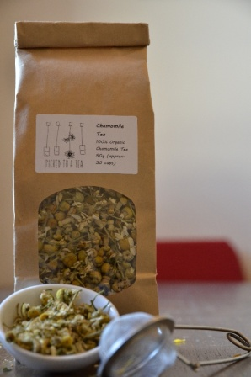
Chamomile tea
Chamomile is a safe and effective herbal tea, which has been used to calm the body from stress, allowing you to sleep longer and deeper. It is a great remedy for nervous heart conditions and palpitations, especially when combined with another herbs called lemon balm. Enjoy these two teas on there own or combined with other flavored florals, unique to the Picked- to - a tea range. Tummy tea combines chamomile, lemonbalm and peppermint, so will have calming effects on both your tummy and heart. Available at the clinic, Cafe Derailieur, Wang Wholefoods and La Bella Rocca fruit.

Recipe of the Month

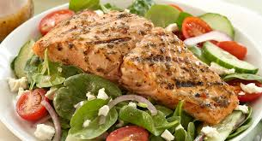
Baked salmon with antioxidant salad
3 Salmon Fillets/Steaks
1 Lemon Juiced
Cracked Pepper
Line baking disk with foil and baking paper. Place Salmon fillets/ or steaks in the dish. Drizzle lemon juice over the fish. Crack pepper over fish to taste. Cover dish with foil.
Bake in 180 degrees oven for 20-30 minutes. Fish is cooked when is no longer see through.
Antioxidant Salad
2 cups Fresh Silverbeet/ Baby Spinach
2 cups Rocket/Endive/Chicory
2 cups Beetroot Leaves
1 Grated Carrot
1 Grated Beetroot
2 tbs Fresh Olive Oil
½ Lemon Juiced
Tomato
garlic
Finely slice fresh silverbeet leaves. Combine all ingredients in salad bowl. Mix olive oil, garlic and lemon juice together to make dressing and drizzle over salad.

