Headaches
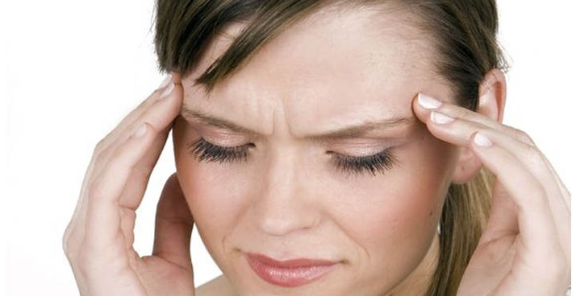
When headaches occur, it is not a sign from your body that you need Panadol! Headaches are a distress signal which occurs when your body fails to stay well.
Here are the Naturopath’s top five list of the most common headache types by location and their underlying causes...
- Pain at the back of the head to neck - Spine and muscles need to be checked and realigned. Poor posture – your computer and desk position may need to be looked at too.
- Pain on top of the head – Blood pressure changes. Can be low blood pressure if vague, dizzy or dehydrated and the pain is tight and constrictive. Can be high blood pressure if the pain in pounding. You need to have your blood pressure checked.
- Pain over the bridge of the nose, cheeks and around eyes – Hay fever and sinus pressure.
- Pain near forehead and eyes – Digestive upset, liver sluggishness often caused by a reaction to rich food or drink. Can be hormonal too.
- Pain near temples at side of head – Blood sugar change, over eating of sugar foods and drinks, migraine – like change in blood flow caused by spasm of the blood vessel walls. Can be brought on by a digestive reaction to sugar or preservatives. Can be hormonal too.

(A less common headache which is a sudden onset, all over head pain with fever is often caused by a virus.)

Headaches which come very rarely, can be fixed by a couple of glasses of extra water and a short rest and leave the body quickly are not really a problem, but if you seem to be getting headaches more often, it may be time to explore the cause and cure.

As you can see from the above, there are many reasons why your body may give you the distress signal.
The take home message is this...A headache is like a red warning light on the dashboard of a car. Do you put a sticker over it and cover it up or do you find the reason why it is happening? There are many reasons for headaches and each has a different treatment. Finding the cause is the best solution for your body.
By Michelle Cose, Naturopath @ North East Natural Health Centre

