THE PERFECT POO?
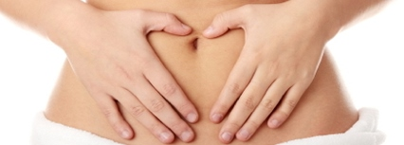

Poo is a perfectly natural by-product of digestion.
Touch the tip of your thumb together with the tip of the pointer finger to make the A.O.K sign. This is how wide your poo will be when you are having enough plant based fibre.
An every day stool is essential. Your body has an inside temperature of 37 degrees. Food that does not clear daily from the bowels will ferment at this temperature causing bloating, unnatural gas, irritable bowels and pre-cancerous conditions of the colon.
Dr. Hiromi Shinya (YOUTUBE), work expert and inventor of the colonoscopy shows us in a video not for the faint-hearted that our bowel conditions are mostly a direct result of our food and drink choices.
Here are the Naturopaths top 5 tips
- On Dr.Shinya’s advice, an 85% plant based diet of wholegrains, legumes, beans, fruit and vegetables with less meat and dairy and the addition of quality alkaline water creates a pristine bowel environment.

- For soft, smooth and easy to pass stools increase your water and consider alkaline water for additional cleansing and protection.

- Avoid Laxatives. They irritate and blacken your inner bowel linings. Change your food and drink choices instead.

- For an easier to pass stool, soak Flaxseeds and Chia seeds (a tablespoon of each) in a little water overnight and add Slippery Elm Bark Powder to your breakfast.

- Flour constipates especially white flour. Eat wholegrains with the outer husk on such as whole oats, brown rice, and natural museli.

Don’t be afraid to look at your poo to see how well your digestion behaved. Seek help if needed and Email us for recipes for yummy brown rice breakfasts too.
By Michelle Cose, Naturopath @ North East Natural Health Centre

